**LAB 5**

**Q1.**

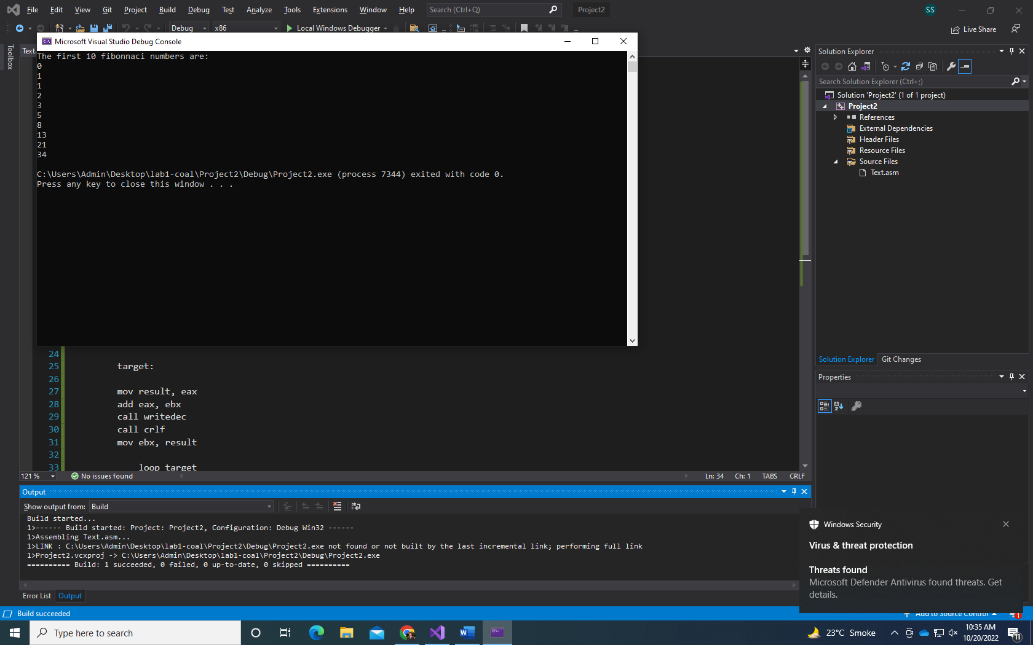

Include irvine32.inc

.data

result DWORD ?

str1 BYTE "The first 10 fibonnaci numbers are: ", 0

.code

main PROC

MOV eax, 1

MOV ebx, 0

MOV ecx, 8

MOV edx, OFFSET str1

CALL WriteString

CALL Crlf

mov result, eax

mov eax, ebx

call writedec

call crlf

mov eax, result

call writedec

call crlf

target:

mov result, eax

add eax, ebx

call writedec

call crlf

mov ebx, result

loop target

exit

main ENDP

end main

**Q2.**

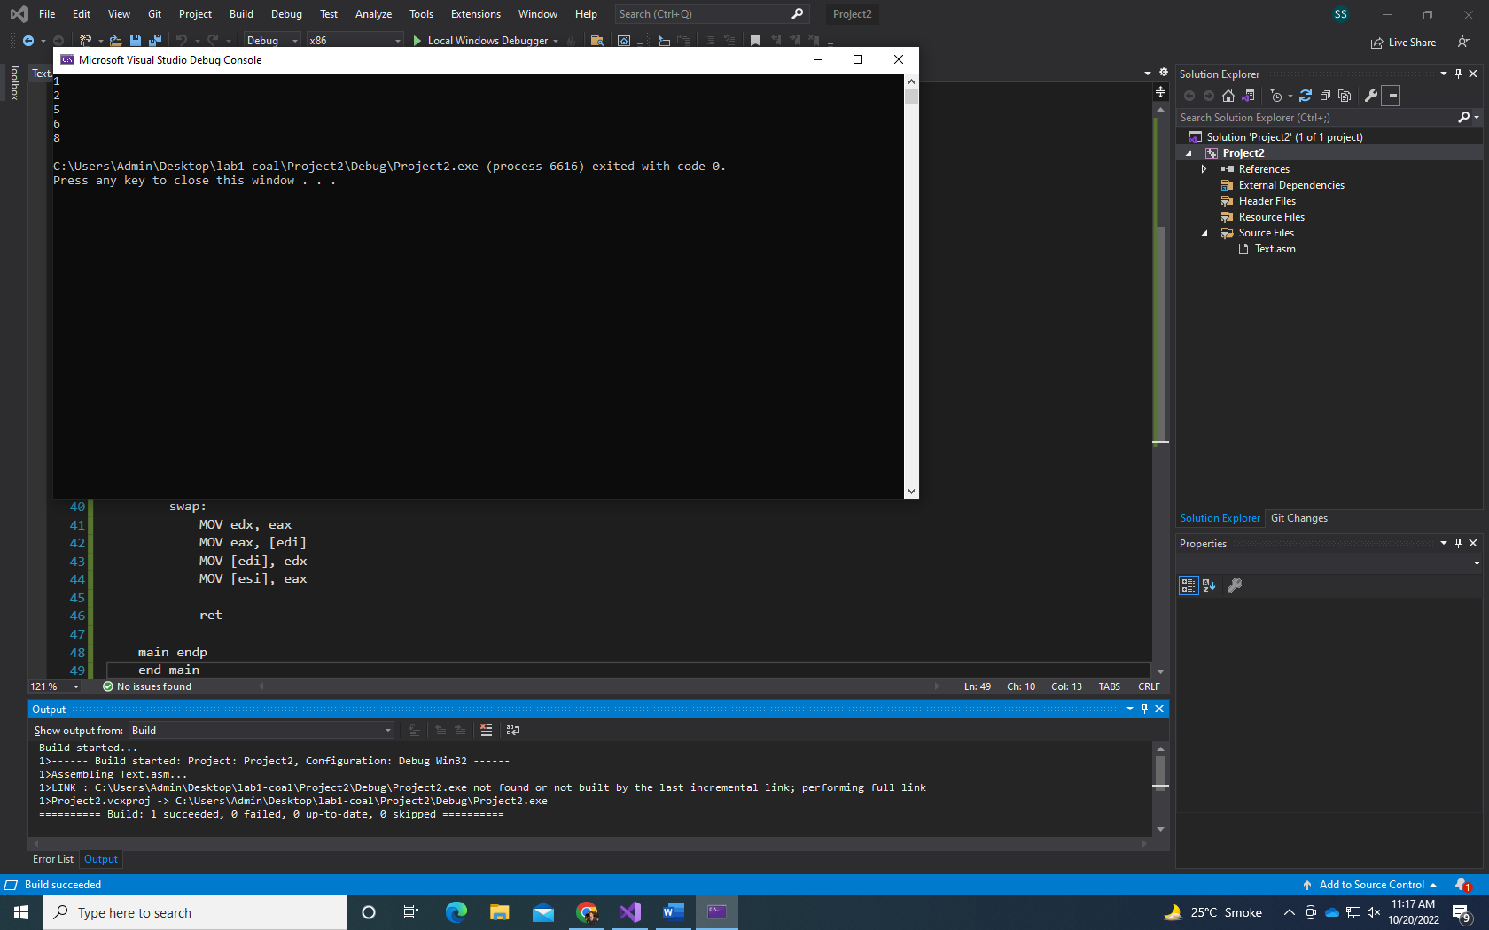

Include Irvine32.inc

.data

arr1 DWORD 8,5,1,2,6

.code

main PROC

MOV esi, OFFSET arr1

MOV ecx, 5

MOV edx, dword ptr 0

L1:

MOV edi, esi

MOV eax, [esi]

MOV ebx, ecx

L2:

cmp [edi], eax

JGE around

call swap

around:

ADD edi, 4

loop L2

ADD esi, 4

MOV ecx, ebx

Loop L1

MOV ecx,5

MOV esi, OFFSET arr1

print:

MOV eax, [esi]

call WriteDec

Call crlf

ADD esi, 4

loop print

exit

swap:

MOV edx, eax

MOV eax, [edi]

MOV [edi], edx

MOV [esi], eax

ret

main endp

end main

Q3.

A 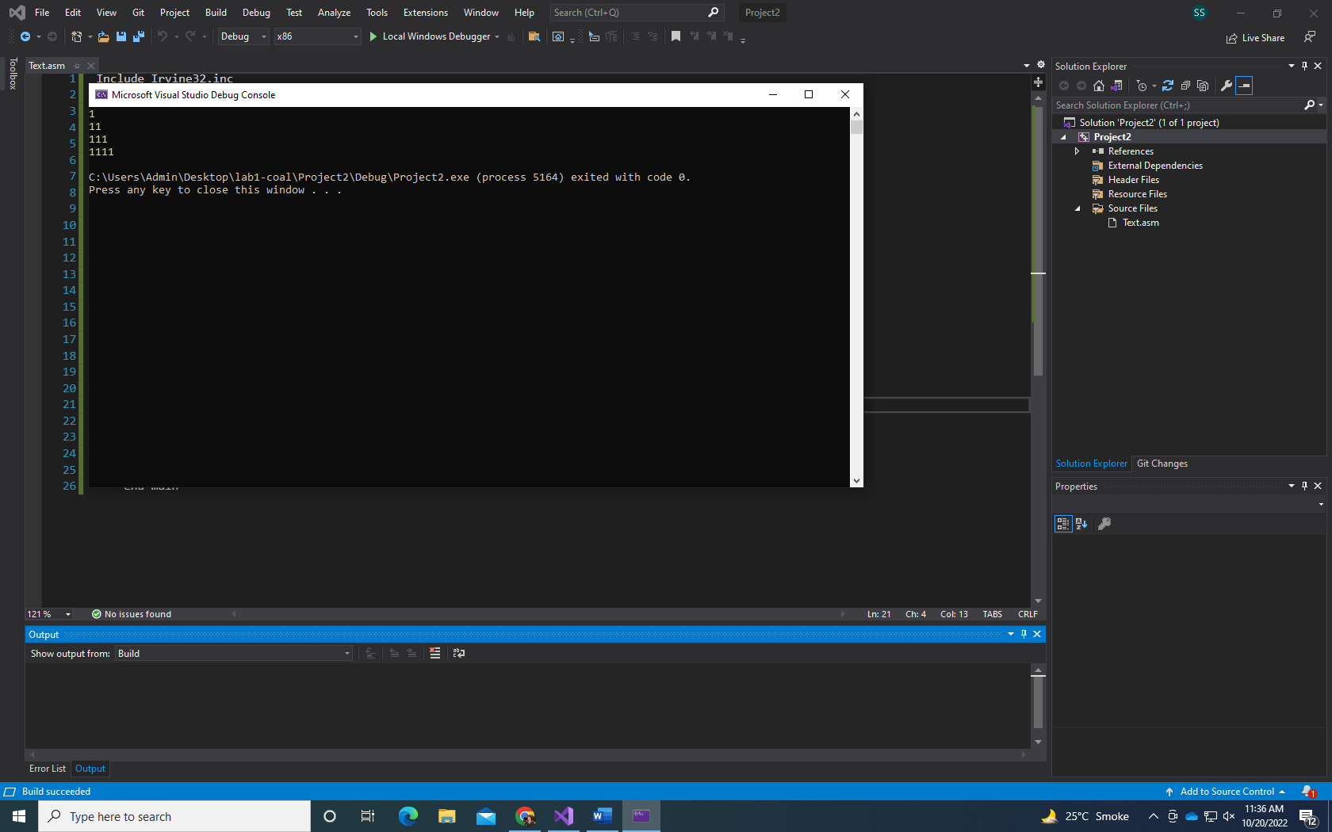

Include Irvine32.inc

.data

count DWORD 1

.code

main PROC

MOV ecx, 4

MOV eax, 1

a1:

MOV edx, ecx

MOV ecx, count

a2:

call WriteDec

loop a2

call crlf

inc count

MOV ecx, edx

loop a1

exit

main endp

end main

Q3

B 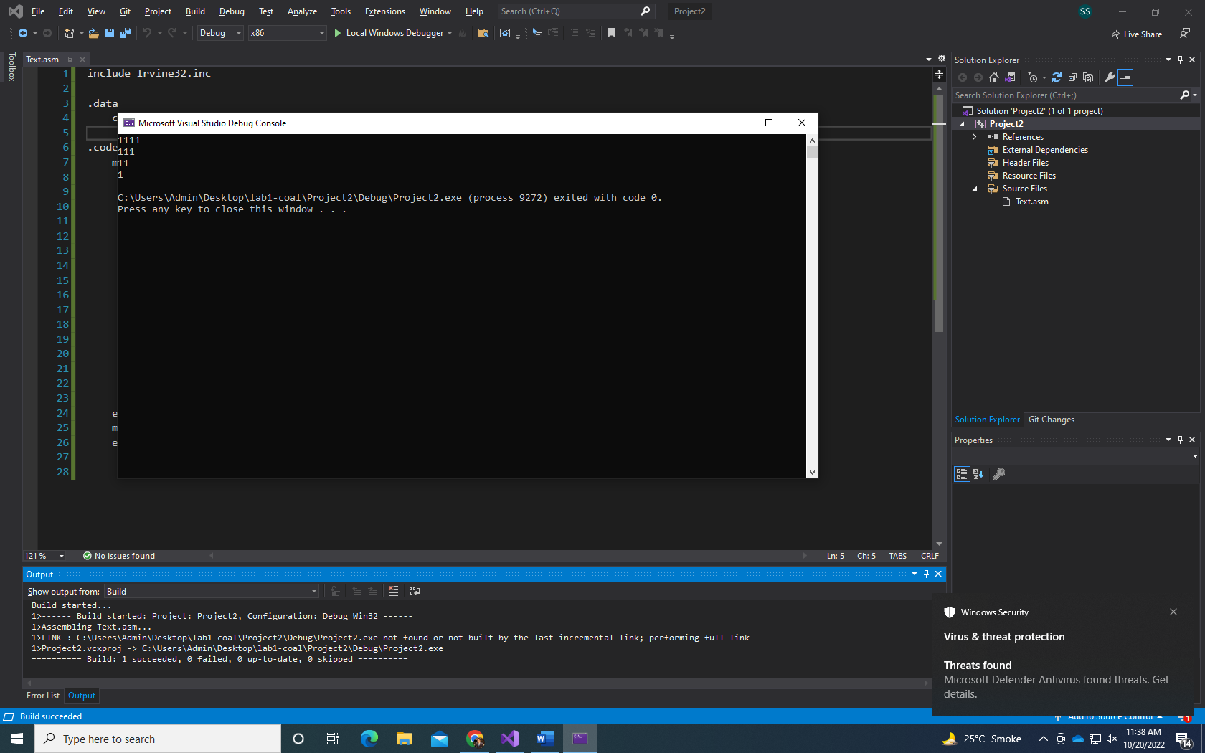

include Irvine32.inc

.data

count DWORD 4

.code

main PROC

MOV ecx, 4

MOV eax, 1

a1:

MOV edx, ecx

MOV ecx, count

a2:

call WriteDec

loop a2

call crlf

dec count

MOV ecx, edx

loop a1

exit

main endp

end main

Q3

C 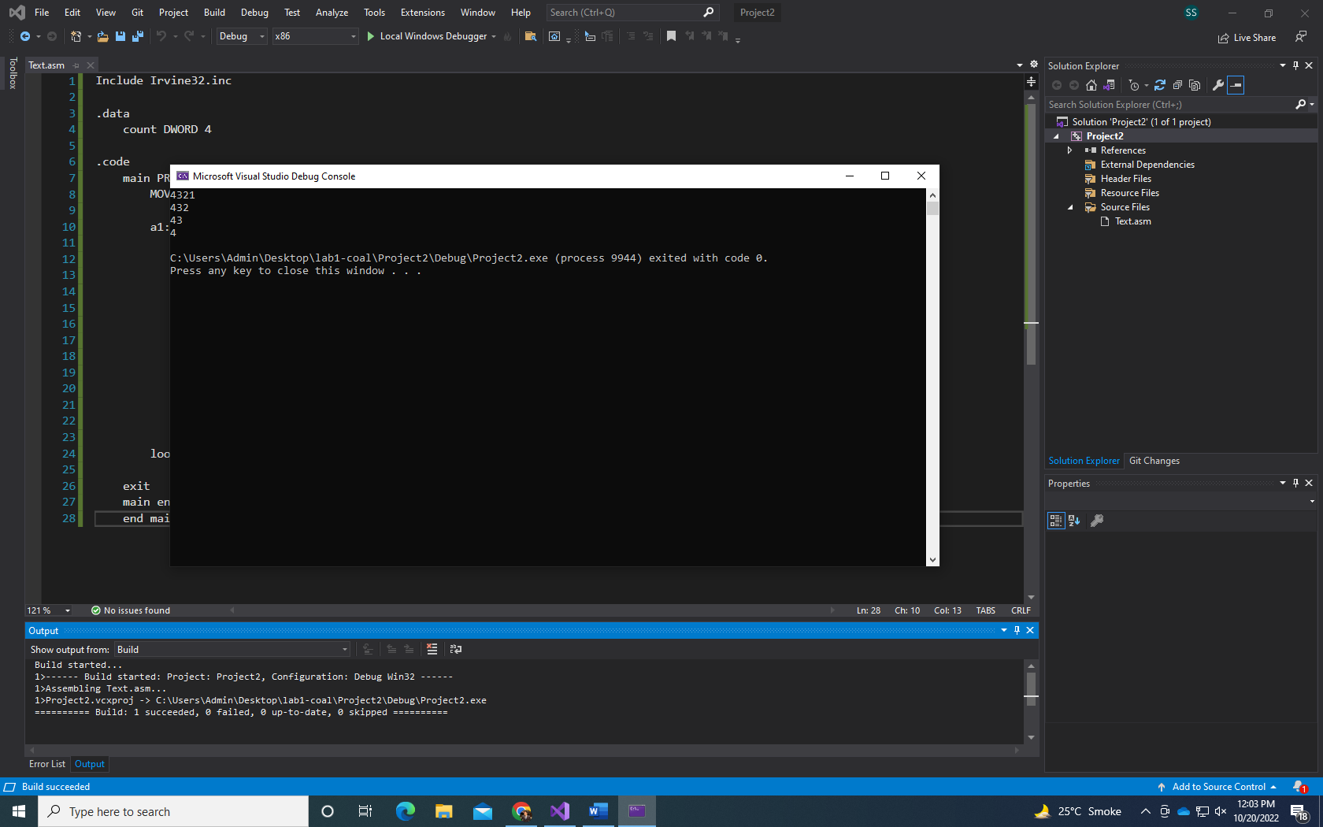

Include Irvine32.inc

.data

count DWORD 4

.code

main PROC

MOV ecx, 4

a1:

MOV edx, ecx

MOV ecx, count

MOV eax, 4

a2:

call WriteDec

dec eax

loop a2

call crlf

dec count

dec eax

MOV ecx, edx

loop a1

exit

main endp

end main

Q3 d

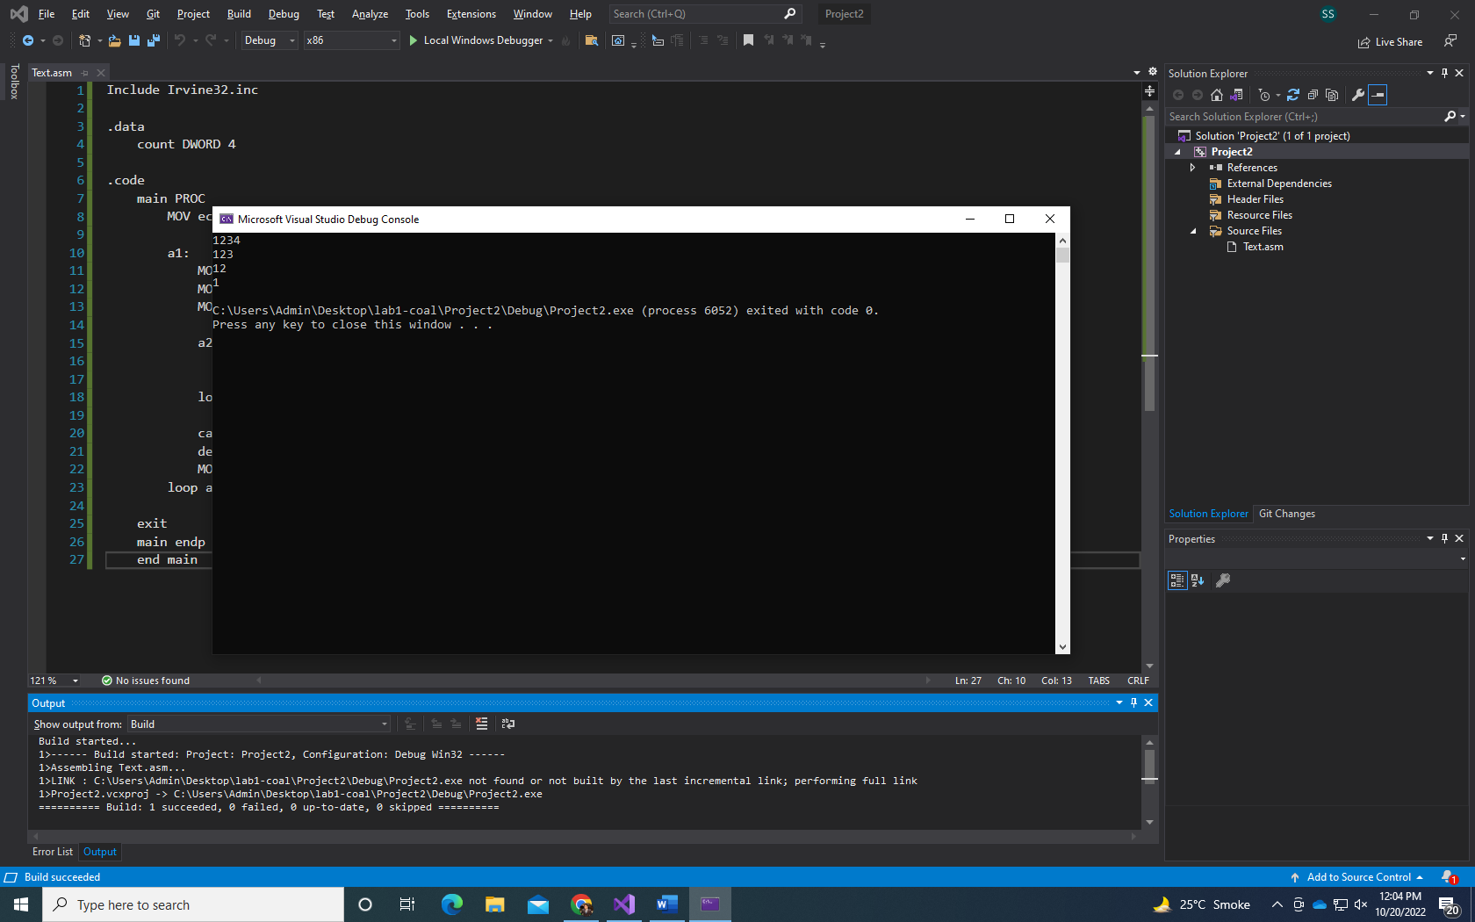

Include Irvine32.inc

.data

count DWORD 4

.code

main PROC

MOV ecx, 4

a1:

MOV edx, ecx

MOV ecx, count

MOV eax, 1

a2:

call WriteDec

inc eax

loop a2

call crlf

dec count

MOV ecx, edx

loop a1

exit

main endp

end main

Q4.

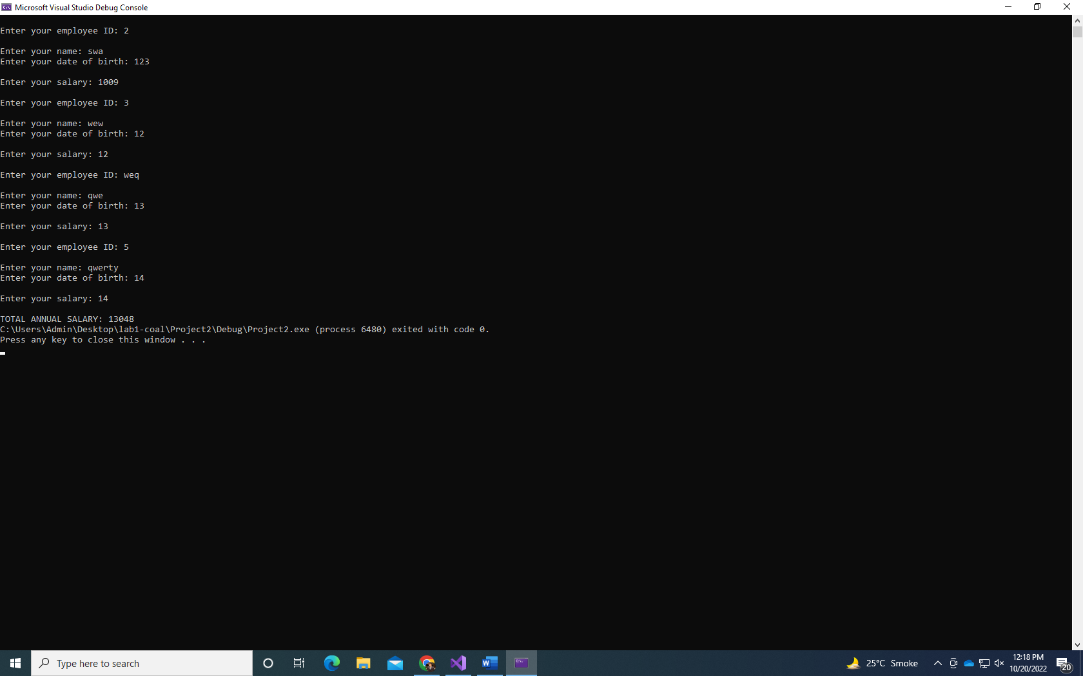

INCLUDE Irvine32.inc

.data

ID1 BYTE "Enter your employee ID: ", 0

Name1 Byte "Enter your name: ", 0

Birth BYTE "Enter your date of birth: ", 0

Salary1 BYTE "Enter your salary: ", 0

ID DWORD 5 DUP(?)

temp BYTE 25 DUP(0)

DOB DWORD 5 DUP(?)

SALARY DWORD 5 DUP(?)

print BYTE "TOTAL ANNUAL SALARY: ",0

.code

main PROC

mov ecx,5

mov esi,0

L1:

MOV edx, OFFSet ID1

call WriteString

call ReadDec

mov ID[esi], eax

call Crlf

MOV edx, OFFSet Name1

call WriteString

mov edx, OFFSET temp

call ReadString

MOV edx, OFFset Birth

call Writestring

call ReadDec

mov DOB[esi],eax

call Crlf

MOV edx, OFFSet salary1

call WriteString

call ReadDec

mov SALARY[esi],eax

call Crlf

add esi,4

loop L1

mov ecx,5

mov eax,0

mov esi,0

L2:

add eax,SALARY[esi]

add esi,4

Loop L2

mov edx,OFFSET print

call writestring

call WriteDec

exit

main ENDP

END main

Q5.

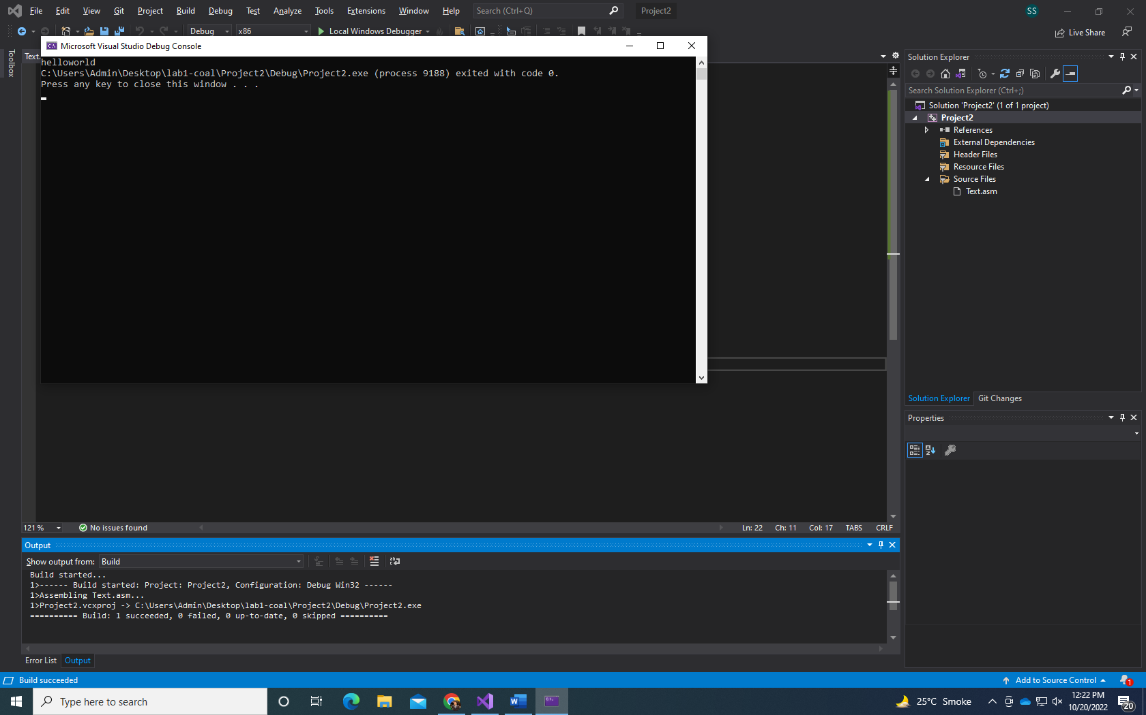

INCLUDE Irvine32.inc

.data

source byte "helloworld",0

target byte 12 dup(?)

.code

main PROC

mov esi, 0

mov ecx, LENGTHOF source

str1:

mov al,source[esi]

mov target[esi],al

inc esi

loop str1

mov edx, offset target

call writestring

exit

main ENDP

END main

Q6.

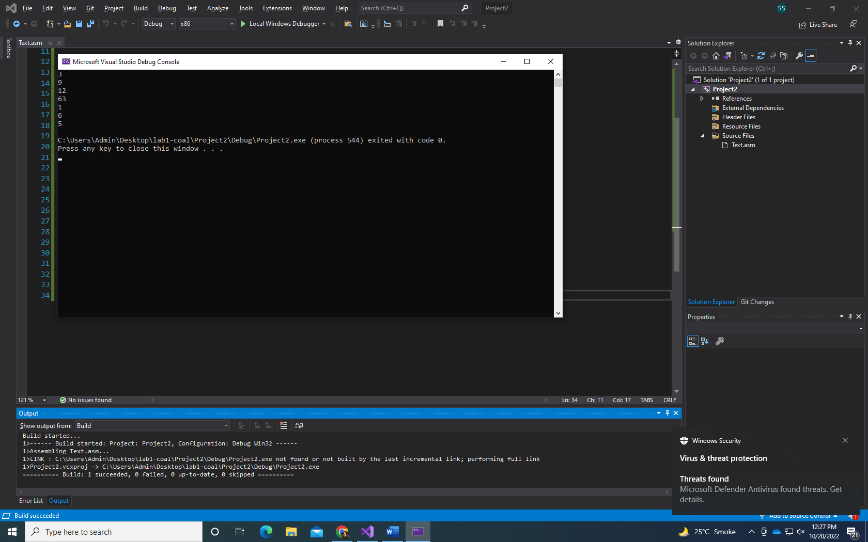

Include Irvine32.inc

.data

arr1 DWORD 5, 6, 1, 63, 12, 9, 3

.code

main PROC

MOV esi, 0

MOV edi, sizeof arr1

SUB edi, 4

target:

MOV eax, arr1[esi]

XCHG arr1[edi], eax

MOV arr1[esi], eax

ADD esi, type arr1

SUB edi, type arr1

cmp esi, edi

JNE target

MOV ecx, 7

MOV esi, OFFSET arr1

l1:

MOV eax, [esi]

call WriteDec

call crlf

ADD esi, type arr1

loop l1

exit

main endp

end main